Design Principles - YAGNI (You Aren’t Gonna Need It)
# Source: AI Source: Provided by: [Data Path: Persons Table -> ID Column: 1, Name_En Column: Motasem Essam] -> From: [ChatGPT] on [1/23/2026]
YAGNI is the principle of not adding functionality until it is actually needed. Avoid building features “just in case” — focus only on what is required today.
👉 Think of it like buying only the furniture you need now, not filling your house with things you might use someday.

🔑 Key Points
# Source: AI Source: Provided by: [Data Path: Persons Table -> ID Column: 1, Name_En Column: Motasem Essam] -> From: [ChatGPT] on [1/23/2026]
• Only implement features when there is a clear, immediate need
• Prevents over-engineering and wasted effort
• Keeps codebase simpler, cleaner, and easier to maintain
• Reduces unnecessary complexity and technical debt

❌ Bad Example
# Source: AI Source: Provided by: [Data Path: Persons Table -> ID Column: 1, Name_En Column: Motasem Essam] -> From: [ChatGPT] on [1/23/2026]
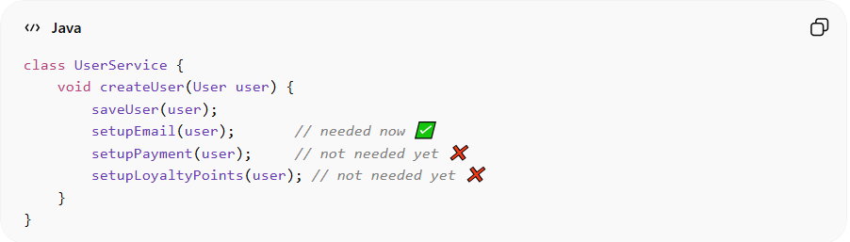
class UserService {
void createUser(User user) {
saveUser(user);
setupEmail(user); // needed now ✅
setupPayment(user); // not needed yet ❌
setupLoyaltyPoints(user); // not needed yet ❌
}
}
Problems:
• Adds complexity for features not currently required
• Increases maintenance burden
• Might never be used → wasted development effort
• Makes system harder to understand

✅ Good Example
# Source: AI Source: Provided by: [Data Path: Persons Table -> ID Column: 1, Name_En Column: Motasem Essam] -> From: [ChatGPT] on [1/23/2026]
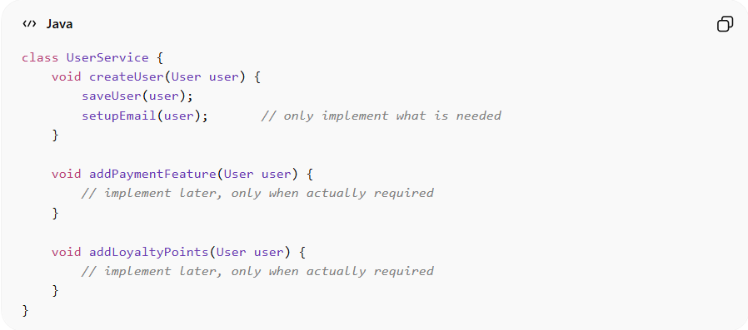
class UserService {
void createUser(User user) {
saveUser(user);
setupEmail(user); // only implement what is needed
}

void addPaymentFeature(User user) {
// implement later, only when actually required
}

void addLoyaltyPoints(User user) {
// implement later, only when actually required
}
}
Benefits:
• Focus on immediate requirements → simpler, cleaner code
• Easier to maintain and extend later
• Prevents unnecessary work and wasted resources
• Reduces complexity and risk of bugs

⚡ When to Apply
# Source: AI Source: Provided by: [Data Path: Persons Table -> ID Column: 1, Name_En Column: Motasem Essam] -> From: [ChatGPT] on [1/23/2026]
• Always — especially in agile and iterative development
• Works best with short, incremental releases
• Combine with KISS and DRY for maximum simplicity and maintainability
• Useful for enterprise systems, microservices, and evolving projects

